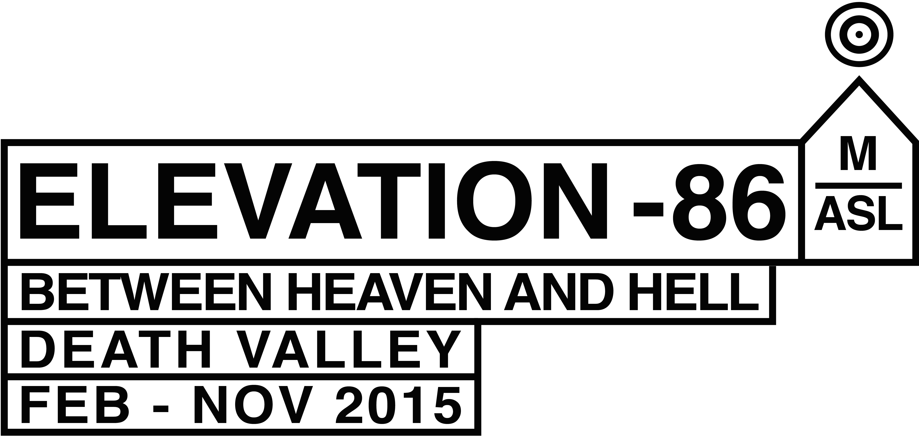

*Background / Elevation 1049*  
  
Elevation -86 will be the second iteration in a series of site-specific shows that began earlier this year with Elevation 1049, an invitational show of over twenty Swiss artists that took as their backdrop the Swiss mountain village of Gstaad. (See <http://www.elevation1049.org>) By exchanging the white cube for the snow-covered landscape, the idea was to probe the extent to which a show could be both geographically diverse - works were distributed across a wide territory - and curated by the social and natural landscapes to which it responded. Organized according to the principle of elevation (as measured in meters above sea-level) the show was also intended to provoke questions about territory and place as they were rendered through new types of artistic mapping.  
  
*Elevation -86 / Death Valley*  
  
Death Valley's aridity, heat and lack of population make it almost the exact opposite of the iconic, picture-perfect village of Gstaad and yet like Gstaad it is a place that has captured the imagination of those all over the world. For outsiders at least, it seems to embody many of the myths of the American West, of a culture formed in the crucible where life-defying wilderness and human ambition are at permanent odds. Like Elevation 1049, Elevation -86 (so named after the lowest point in the US at 86 meters below sea level) will be created around the idea of a map, for which the Death Valley National Park is itself rendered as expanded exhibition space.   
  
*Death Valley / Wilderness Act / Curatorial Principle*  
  
Sustainability is not a concept that much informs the machinations of the international artworld, but against a background that at times appears cluttered with art objects, Elevation -86 will attempt to meet the demands of what constitutes art’s obligation to its audiences –as well as its makers - with zero environmental impact. *Leave No Trace*, an ethic of outdoorsmanship originating with the dirtbag climbers of California’s nearby Yosemite Valley, defines a code of conduct implicit to the underlying curatorial principle of Elevation. Such a premise is in accord with the demands of working within a National Park subject to the Wilderness Act of 1964, which states: “A wilderness, in contrast to those areas where man and his own works dominate the landscape, is hereby recognized as an area where the earth and its community of life are untrammeled by man, where man himself is a visitor who does not remain.” Our intention is to create a new kind of exhibition, one for which the art as much as man himself, is a visitor that does not remain. It will be a show in which the art can be anything and do anything, provided it does not 'disturb the landscape' or ‘degrade the experience of the visitor.’

*Death Valley / Land Art*  
  
Elevation -86 proposes a new type of land art - one whose impact is not on the land itself but on the way we see it. In contrast to the land art of the ’60’s and 70’s it will no longer be defined by men and bulldozers, even as narrative, myth, history, landscape, cartography, dirt and sky continue to present themselves as driving influences. Reversing Robert Smithson’s site / nonsite dialectic, Death Valley will itself be a non-site for which a web-site becomes the primary location. Actions and interventions that take place within the physical realm of Death Valley will be recorded and documented on the website and accompanying publications.  
  
*Elevation -86 / Timeline*  
  
We have begun to invite artists to propose artworks keeping in mind they will need to be done in observance of the principles of the Wilderness Act and in collaboration with the Parks Service. For a period of nine months starting in February 2015, the curators and LUMA& Foundation will work with the artists to execute artworks within the hostility of the Death Valley region the record of which will then form the online manifestation of the show. Artworks may be actualized at any time during a nine month period ending in November 2015, which will be celebrated as the public ‘opening’ of Elevation -86.  
  
I hope this helps in terms of understanding the show that we are yet in the process of creating.

Recources:

The link below will take you to the National Park website where you will find links to the Stewardship Plan which is the most accessible version of the parks policies in regards to the Wilderness Act, and a map of Death Valley NP that includes the Wilderness boundaries within the park.

<http://www.nps.gov/deva/naturescience/wilderness.htm>

Below is the link to Leave No Trace:

https://lnt.org/learn/7-principles